

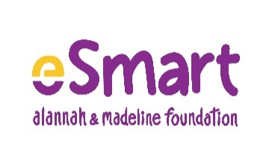

**eSmart Schools Framework Outcome Evaluation**

Aug 2022

# Contents

Contents 1

List of Tables 2

Acknowledgements 2

Executive Summary 3

Background 4

Aim 5

Methodology 5

Demographics of schools participating in the self-assessment tool: 2021 & 2022 5

Results 5

Part A Results 5

Part B Results 8

Summary – quantitative results 11

Discussion 11

Conclusion 12

References 12

Appendices 12

# List of Tables

**No table of figures entries found.**

List of Figures

Figure 1. Participants by school sector 4

# Acknowledgements

# Executive Summary

# Background

# Aim

# Methodology

Quant: Compare results from all schools – 2021 and 2022

## Demographics of schools participating in the self-assessment tool (SAT): 2021 & 2022

*[Pie charts side-by-side: 2021 and 2022. Sector, Type, SES, ADII, Metro/non-metro; 2022 only:* ***Engagement A (Low, High) and Engagement B (Low, Medium, High)***

*Example (2021: stripes; 2022: solid):*

2021 2022

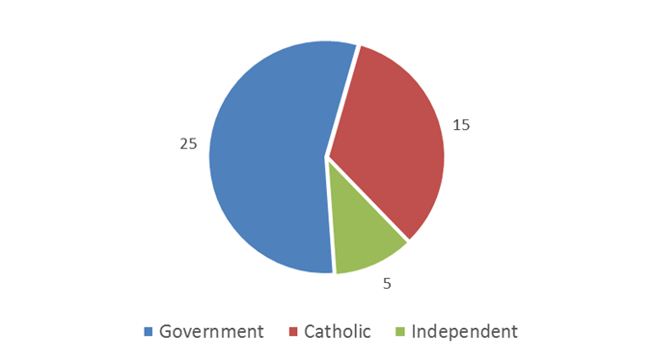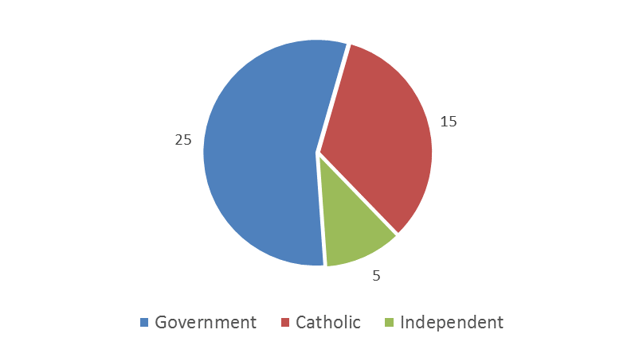

Figure 1. Participants by school sector

# Results

*[Repeat charts from 2021 report, but with comparison to 2022 data. So, for example, bar charts would show both 2021 data (striped) next to 2022 data (solid). If charts get too crowded/too hard to read, can present side-by-side or vertically. Test for any statistically significant differences and indicate in chart.]*

### Part A Results

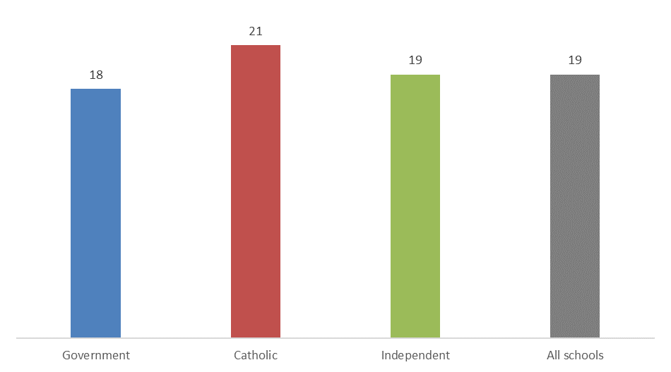

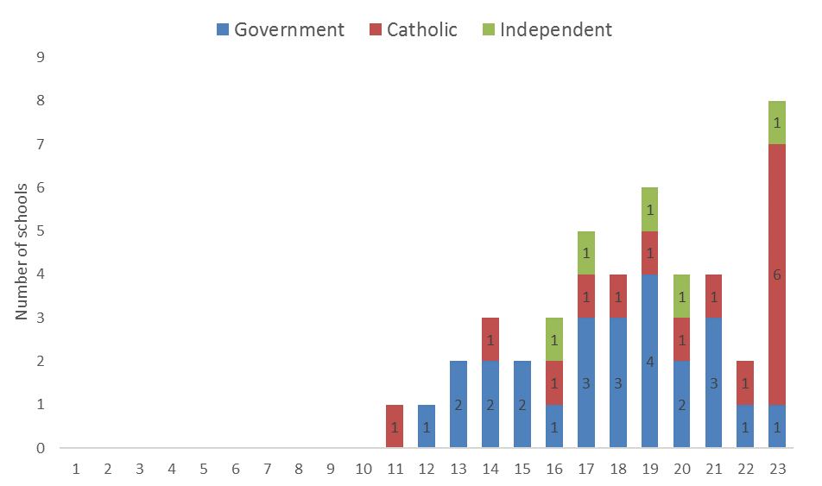

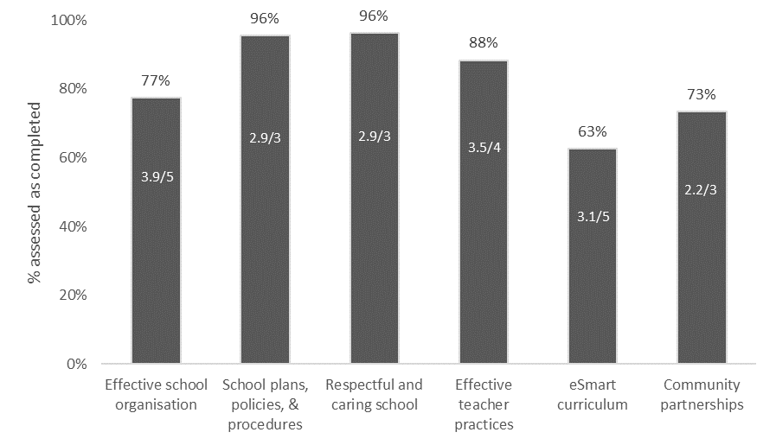

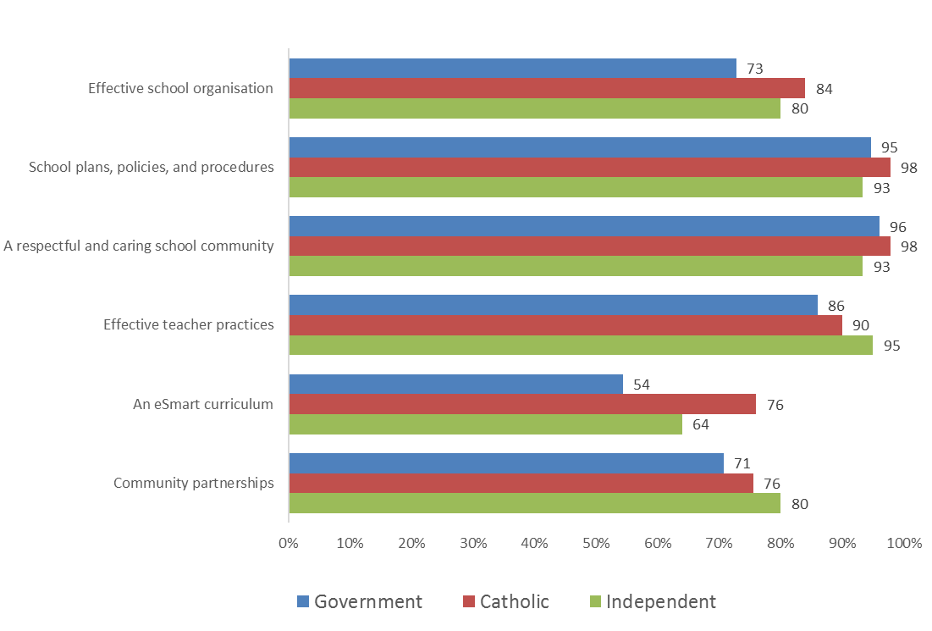

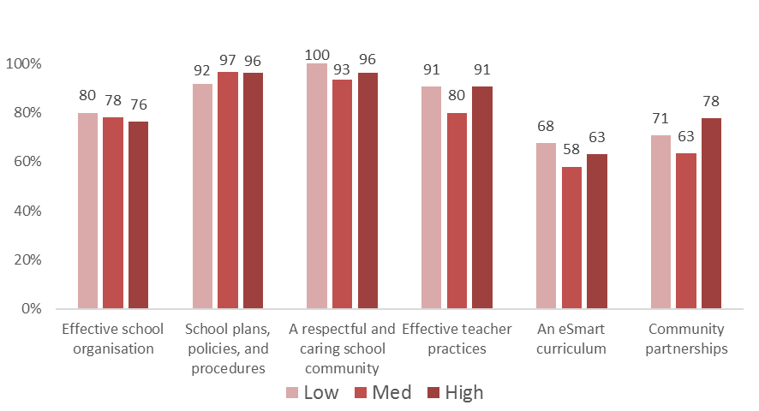

*(include all other demographics)*

### Part B Results

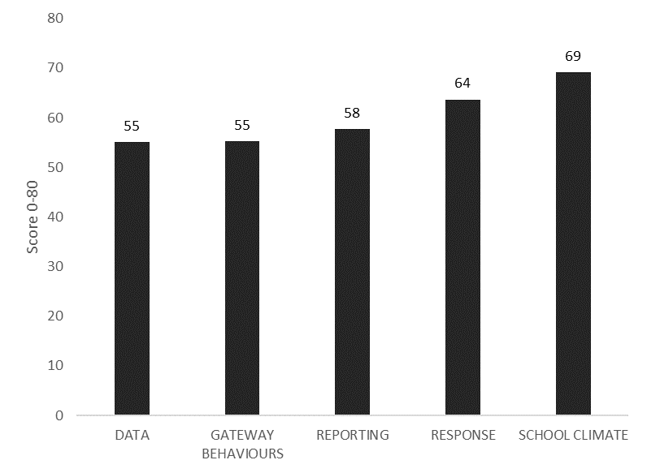

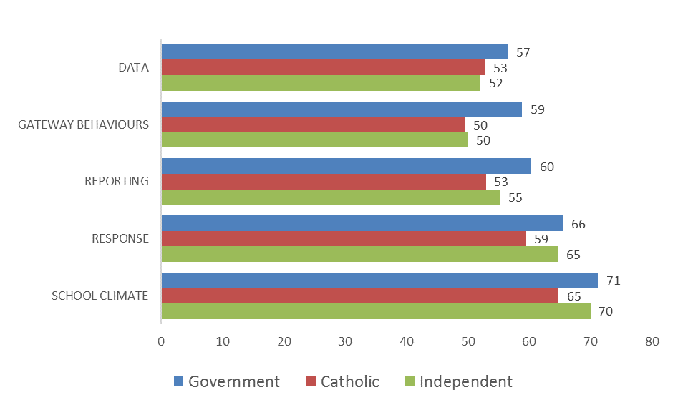

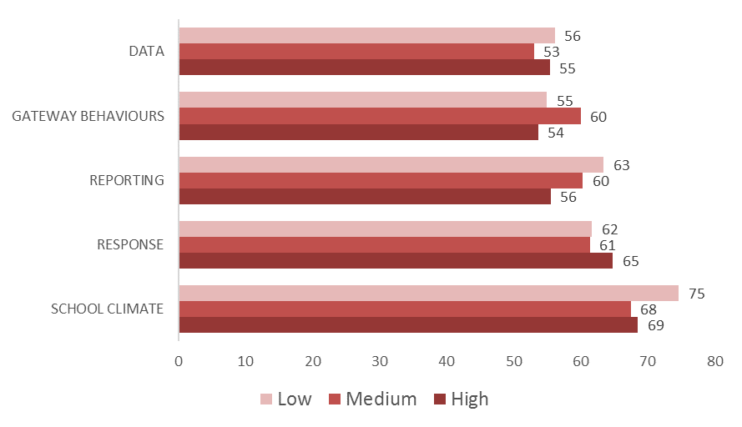

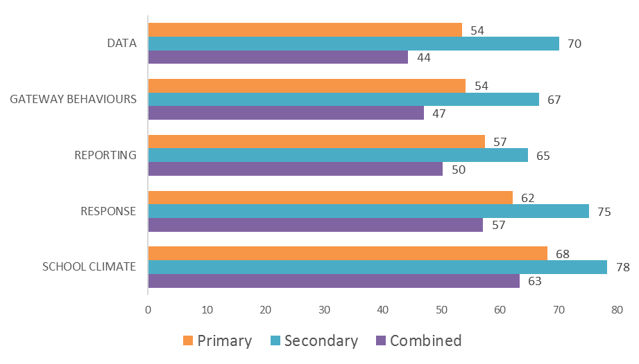

(and all other demographics)

#### Overall progress (total score by quartile)

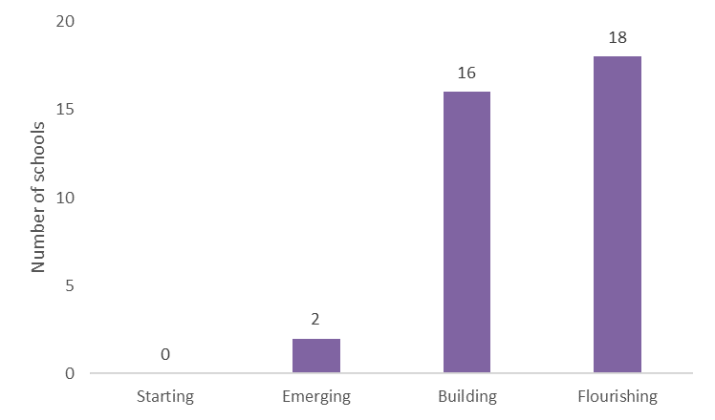

## Summary – quantitative results

# Discussion

[Integration of quant and qual results]

# Conclusion

# References

# Appendices